S01 | Chassis Bumper (25x2x2) | $ 300.00 | 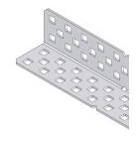
S02 | Chassis Bumper (15x2x2) | $ 175.00
S03 | Long Bar (25x1) | $ 75.00 | 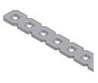
S04 | Chassis Rail (1x2x15) | $ 175.00 | 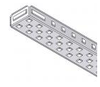
S05 | Chassis Rail (1x2x25) | $ 275.00
S06 | Chassis Rail (1x2x35) | $ 450.00
S07 | Long Angle Bar (30) | $ 200.00 | 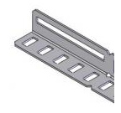
S08 | Flat Plate (5x5) | $ 100.00 | 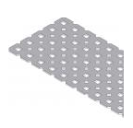
S09 | Flat Plate (5x15) | $ 300.00
S10 | Flat Plate (2x25) | $ 500.00
S11 | C Plate (15x2x1) | $ 200.00 | 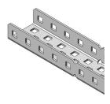
S12 | C Plate (25x2x1) | $ 300.00
S13 | C Plate (25x5x1) | $ 750.00

S14 | L Plate (25x1) | $ 200.00 | 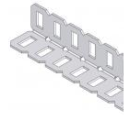
S15 | L Plate (35x2) | $ 500.00
S16 | Male Rivet | $ -
S17 | Female Rivet | $ -
S18 | Pivot | $ 20.00 | 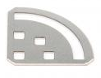
S19 | Plus Gusset | $ 40.00 | 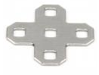
S20 | Gusset | $ 40.00 | 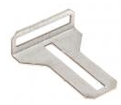
S21 | Linear Slide (25) | $ 400.00 | 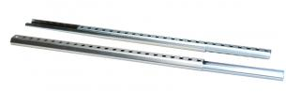
S22 | Straw | $50
S23 | Popsicle Stick | $50
S24 | Grippy Material  (18”x 2”) | $100 | 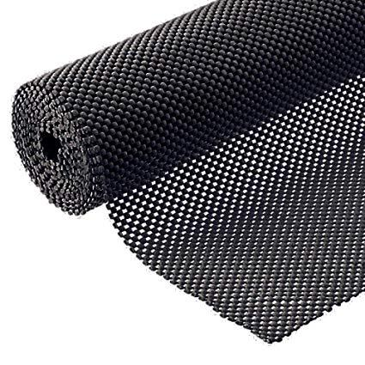
S25 | Braided Sleeve (1ft) | $75 | 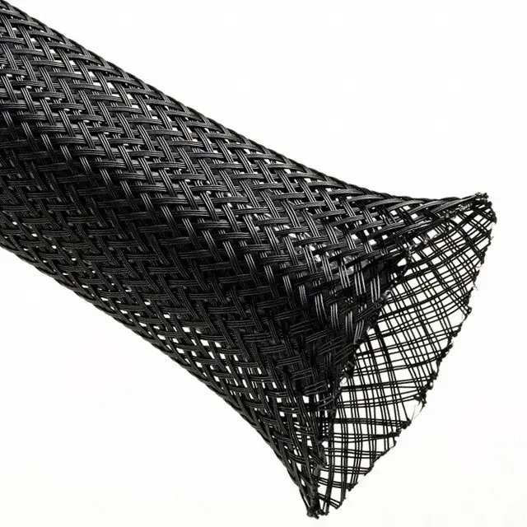
S26 | Braided Sleeve (1ft) | $75
S27 | Braided Sleeve (1ft) | $75

B01 | Fully Threaded Beams (1/2") | $ 10.00 | 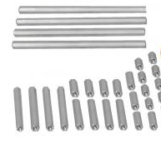
B02 | Fully Threaded Beams (1") | $ 20.00
B03 | Partially Threaded Beams (2") | $ 40.00
B04 | Partially Threaded Beams (3") | $ 60.00
B05 | Square Bar (2") | $ 20.00 | 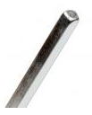
B06 | Square Bar (3") | $ 30.00
B07 | Square Bar (4") | $ 50.00
B08 | Square Bar (12") | $ 100.00

M01 | Servo (±90°)  (Limit 1 per group) | $ 600.00 | 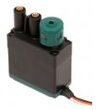
M02 | Motor  (Limit 2 per group) | $ 600.00
M03 | Clutch | $ - | 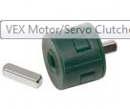
M04 | Clutch Post | $ -

H01 | Washer, Steel |  | 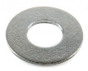
H02 | Washer, Delrin | $ -
H03 | Keps Nut (1/4") | $ - | 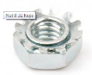
H04 | Lock Nut (1/4") | $ - | 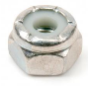
H05 | Screw (8-32x1/4") | $ - | 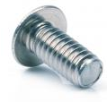
H06 | Screw (8-32x3/8") | $ -
H07 | Screw (8-32x1/2") | $ -
H08 | Screw (8-32x3/4") | $ -
H09 | Plastic Spacer (.318") | $ - | 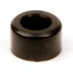
H10 | Plastic Spacer (.182") | $ -
H11 | Collar (with threaded screw) | $ 20.00 | 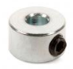
H12 | Bearing Block | $ 15.00 | 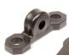
H13 | Bearing Flat | $ 5.00 | 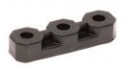
H14 | Lock Plate | $ 50.00 | 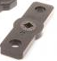

K04 | Hinges | $ 250.00 | 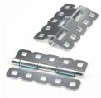

G01 | 12-Tooth Gear | $ 100.00 | 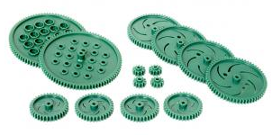
G02 | 36-Tooth Gear | $ 150.00
G03 | 60-Tooth Gear | $ 200.00
G04 | 84-Tooth Gear | $ 250.00
G05 | 19-Tooth Rack Gear | $ 50.00
G06 | 24-Tooth Gear (use with worm gear only) | $ 50.00 | 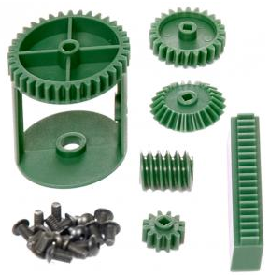
G07 | Worm Gear | $ 200.00
G08 | Differential Kit | $ 150.00
G09 | 24-Tooth Bevel Gear | $ 40.00
G10 | Intake Roller | $ 25.00 | 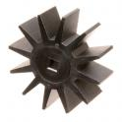
G12 | Bevel Gear Box Bracket | $ 150.00 | 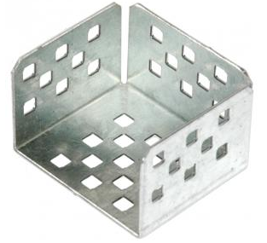
G13 | Worm Gear Box Bracket | $ 100.00 | 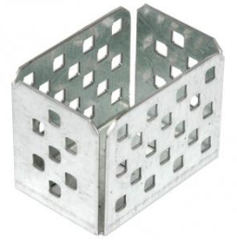
G14 | Rack Gear Box Bracket | $ 100.00 | 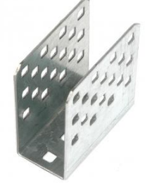

E03 | Wire Y-Split | $ 50.00 | 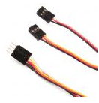
E04 | Short (+/- 6”) Extension Wire | $ 50.00 | 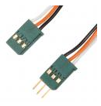
E05 | Long (+/- 24”) Extension Wire | $ 100.00
E06 | Limit Switch | $ 100.00 | 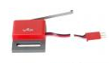
E07 | Bumper Switch | $ 100.00 | 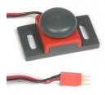
E08 | Line Follower Sensor | $ 150.00 | 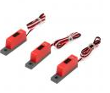
E11 | Potentiometer | $ 150.00 | 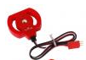
E12 | Optical Shaft Encoder | $ 250.00 | 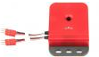

W01 | Wheel (2.75") | $ 125.00 | 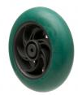
W02 | Wheel (4") | $ 150.00 | 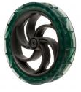
W03 | Wheel (5") | $ 150.00 | 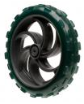
W04 | Omni-wheel (2.75") | $ 200.00 | 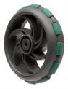
W05 | Omni-wheel (4") | $ 300.00 | 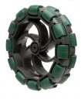

T01 | Tank Tread Links (Linear Feet) | $ 150.00 | 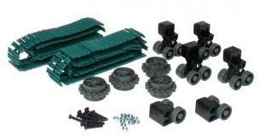
T02 | Tank Tread Drive/Idle Sprocket | $ 75.00
T03 | Bogie Wheel Assembly (4 Wheels) | $ 50.00
T04 | Bogie Wheel Assembly (Idler) | $ 50.00

C01 | Chain Links (Linear Foot) | $ 150.00 | 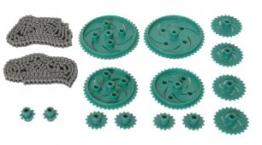
C02 | 10-Tooth Sprocket | $ 75.00
C03 | 15-Tooth Sprocket | $ 100.00
C04 | 24-Tooth Sprocket | $ 125.00
C05 | 40-Tooth Sprocket | $ 175.00
C06 | 48-Tooth Sprocket | $ 250.00

X01 | Cardboard | Free
X02 | Duct Tape (6" strip) | $50.00
X03 | String (per foot) | $20.00
 | Fishing Line (1m) | $20.00
X05 | Hook-up Wire | $50 per Foot

 | Jumper Wire (4)  M-M | $50 | 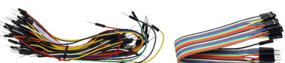
 | Jumper Wire (4)  M-F | $50
 | Jumper Wire (4)  F-F | $50
P02 | 7-Segment Display | $100.00 | 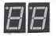
P04 | Buzzer | $75.00 | 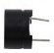
P05 | Capacitors  (10nF and 100nF) | $50.00 | 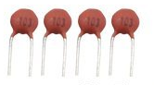
P06 | Rotary Encoder | $200.00 | 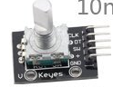
P07 | Potentiometer | $150.00 | 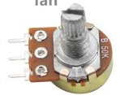
P08 | Shift Register  74HC595N | $300.00 | 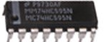
P09 | Switch | $50.00 | 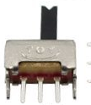
P10 | Fan | $10.00 | 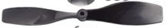
P11 | Accelerometer | $300.00 | 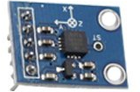
P13 | Transistor  (PNP and NPN) | $100 | 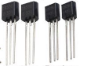
P14 | Resistors Various  (0,1.5,4.7,10,47,100,220,330,470,680,1k,2.2k,3.3k,4.7k,10k,22k,47k,100k,330k,1M,5.1M ) | $ - | 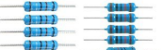
P15 | RGB LED | $ 100
P16 | Optocoupler 4N35 | $75 | 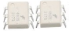
P19 | Diode Rectifier | $40 | 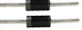
P20 | DC Motor | $250 | 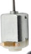
P21 | Dot Matrix Display | $200 | 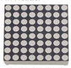
P22 | LEDs | $50 | 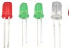
P23 | 12VDC Motor | $1000 | 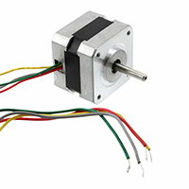
P24 | Arduion Moto Shield V2 | $600 | 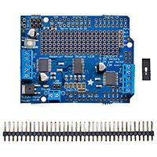
P25 | Zip-Ties | $50
P26 | 9V Battery w/ battery connect snap | $1000 | 